

The Forum of Women in the Environmental Field Presents
Sustainable Buildings Tour

Tuesday, September 21, 2010, 9-10 AM

Optional networking breakfast at 7:30 AM

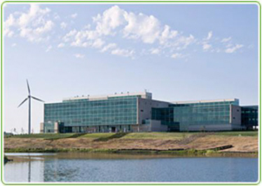
Great River Energy
Join the FWEF for a tour of the Great River Energy headquarters —the first platinum LEED-certified building in Minnesota. One of the most energy-efficient and sustainable buildings in the state, it showcases rooftop solar photovoltaic panels, its own wind turbine, a state-of-the-art geothermal heating and cooling system and multiple atriums to allow maximum daylight. The grounds capture rainwater to use for flushing toilets and irrigation.

To attend, you must register online at www.fwef.org
RSVP by Friday, September 17, 2010

Cost: FREE tour for members. $5 for non-members
Optional networking breakfast—at your own expense

Tour Location: Great River Energy, 12300 Elm Creek Boulevard, Maple Grove
Breakfast Location: 3 Squares Restaurant, 12690 Arbor Lakes Pkwy, Maple Grove

